Name : Abhishek Pundir ;

Course & section : MCA ‘c’;

Roll No : 2001008;

**1. Write a program to use the mathematical operators.**

**Code :-**

**num1 = int(input("Enter first number: "))**

**num2 = int(input("Enter second number: "))**

**print()**

**print("-----------------Common Mathematical Operation-----------------------------")**

**print("Sum of Two Number: " ,num1 + num2)**

**print("Substraction of two num: ", num1 -num2)**

**print("Multiplication of two number: ", num1*num2)**

**print("Division of two number: ", num1 / num2)**

**print("Modulas of two number: ", num1%num2)**

**print("---------------------------------------------------------------------------")**

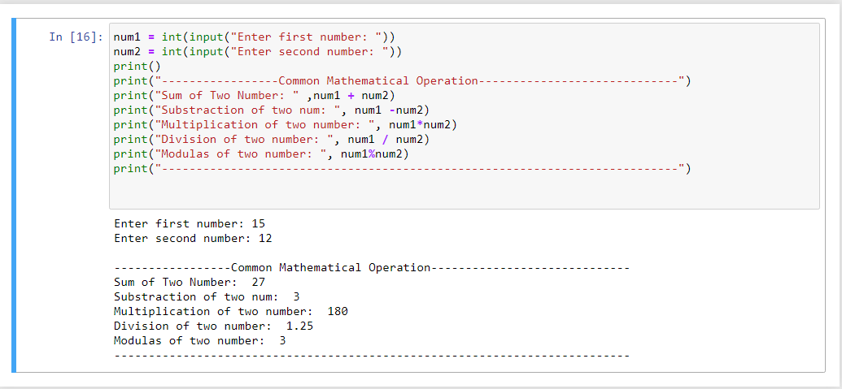

2.Write a program to take a input from user and print the fibonacci series to the terminal number:

**Code :-**

num = int(input("Enter the terminal number: "))

num1 = 0

num2 = 1

print(num1)

print(num2)

for i in range(0,num):

num3 = num1 + num2

print(num3)

num1 = num2

num2 = num3

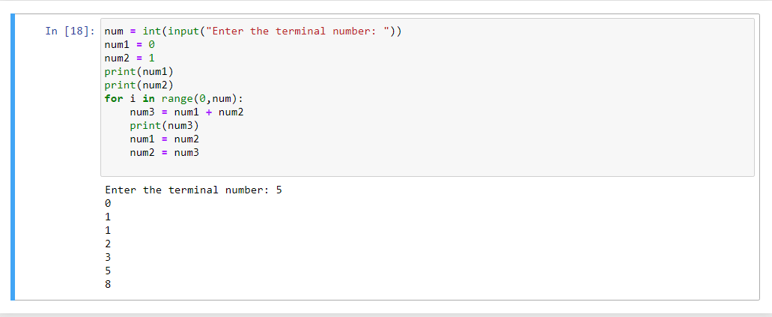

**3. Write a program to take a number from user and print its factorial**

**Code :-**

fect = 1

num = int(input("Enter the number: "))

for i in range(1,num+1):

fect = fect*i

print("Factorial of a number: ",fect)

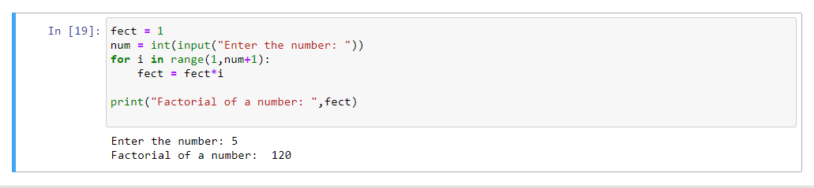

4.Write a program to check whether a given number is a prime or not using loop

**Code :-**

num = int(input("Enter the number: "))

check = False

for i in range(2,num-1):

if num % i == 0:

check = True

break

if check:

print("Number is not prime")

else:

print("Number is prime")

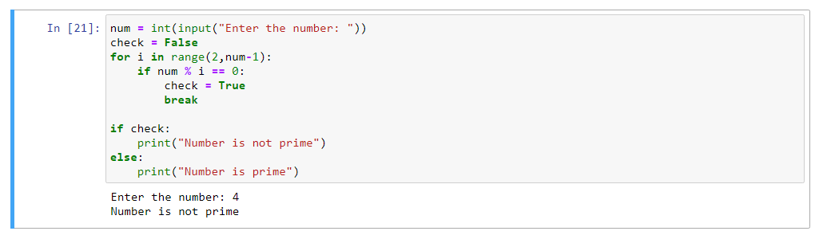

5. Write a program to demonstrate the use of nested if statements.

**Code :-**

num1 = int(input("Enter the first number: "))

num2 = int(input("Enter the second number: "))

num3 = int(input("Enter the third number: "))

i = 13

if (num1 > num2):

if (num1 > num3):

print ("Largest no is ", num1)

else:

print("Largest no is ", num3)

else:

if num2 > num3:

print("Largest number is ", num2)

else:

print("Largest no is ", num3)

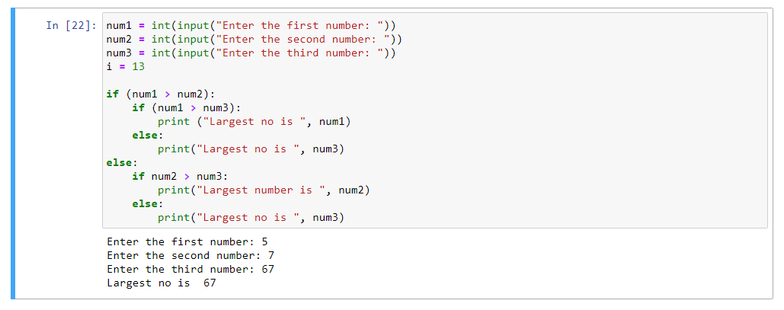

6. Write a program to demostrate the importing of modules of python.

**Code :-**

Import modules

a = int(input("Enter the first number: "))

b = int(input("Enter the second number: "))

num = modules.add(a,b)

print("Sum of a number: ",num)

num1 = modules.mul(a,b)

print("Multiplication of a number: ",num1)

num2 = modules.sub(a,b)

print("Substraction of a two number: ",num2)

**7. Write a program to search the list and sort the list:**

**Code:-**

str=[10,20,220,334,87]

print(sorted(str))

index=str.index(220)

print(index)

index=str.index(87)

print(index)

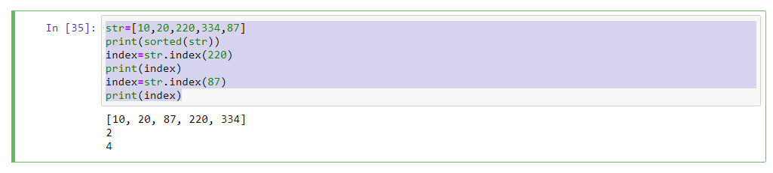

**8. Write a program to illustrate the usage of Tuples.**

**Code:-**

tuple=('abhishek','pundir',22,'male')

print(tuple)

tuple1=('dehradun is a beautyful city')

print(tuple1)

tuple2=('graphic','era','hill','university')

print(tuple2)

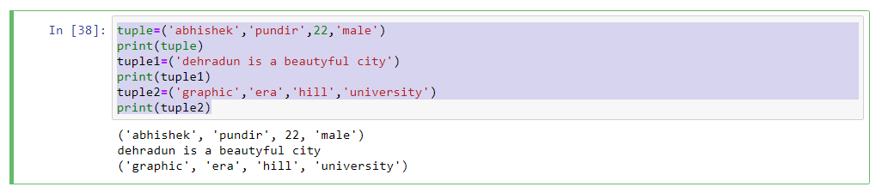

**9. Write a program to illustrate the usage of Dictionaries.**

**Code:-**

d={}

d[1]="Graphic"

d[2]="Era"

d[3]="Hill"

d[4]="University"

d[5]="dehradun"

print(d)

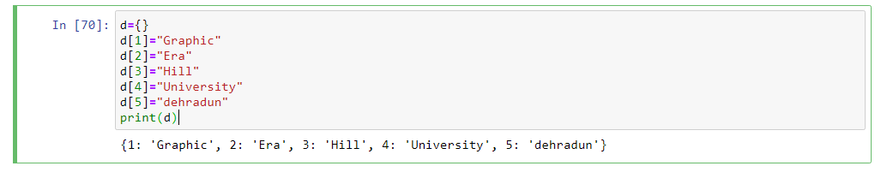

**Programs on Statistical Concepts and introduction to Linear Algebra using Python**

1.Write a program to find the mean. mode and median of the given range of numbers. 2 Write a program to calculate the standard deviation of a given set of numbers.

**Code:-**

import numpy as np

from scipy import stats

dataset = [58, 2, 8, 6, 12, 4]

mean = np.mean(dataset)

print(mean)

median = np.median(dataset)

print(median)

mode = stats.mode(dataset)

print(mode)

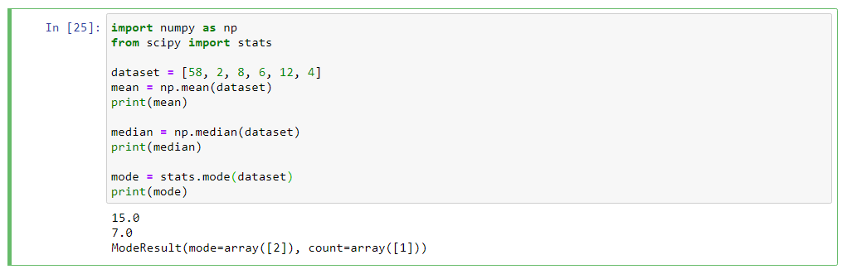

**Code:-**

import statistics

data = [11, 20, 3, 24, 15]

print("Standard Deviation of sample is %s " % (statistics.stdev(data)))

# Standard Deviation of sample is 8.142481194328914

data2 = [9, 1, 2, 5]

print("Standard Deviation of sample is %s " % (statistics.stdev(data2)))

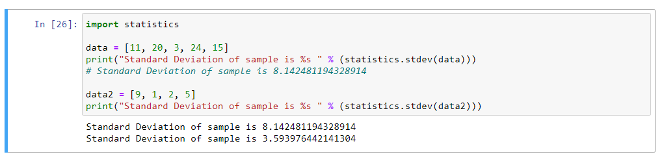

**2. Write a program to calculate the addition of two 3x 3 matrices.**

**Code:-**

matrix1 = [

[1, 3, 5],

[2, 4, 6],

[9, 7, 8]

]

matrix2 = [

[3, 1, 5],

[6, 7, 2],

[8, 4, 9]

]

add = []

for i in range(len(matrix1)):

for j in range(len(matrix1[0])):

add.append(matrix1[i][j] + matrix2[i][j])

print(add)

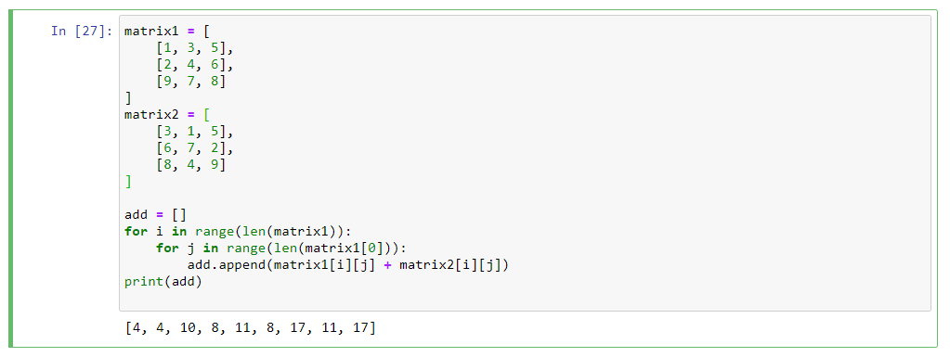

**3. Write a program to calculate the multiplication of two 3x 3 matrices.**

**Code:-**

matrix1 = [

[1, 3, 5],

[2, 4, 6],

[9, 7, 8]

]

matrix2 = [

[3, 1, 5],

[6, 7, 2],

[8, 4, 9]

]

matrix = [

[0, 0, 0],

[0, 0, 0],

[0, 0, 0]

]

add = []

for i in range(len(matrix1)):

for j in range(len(matrix[0])):

for k in range(len(matrix2)):

matrix[i][j] += matrix1[i][k] * matrix2[k][j]

for res in matrix:

print(res)

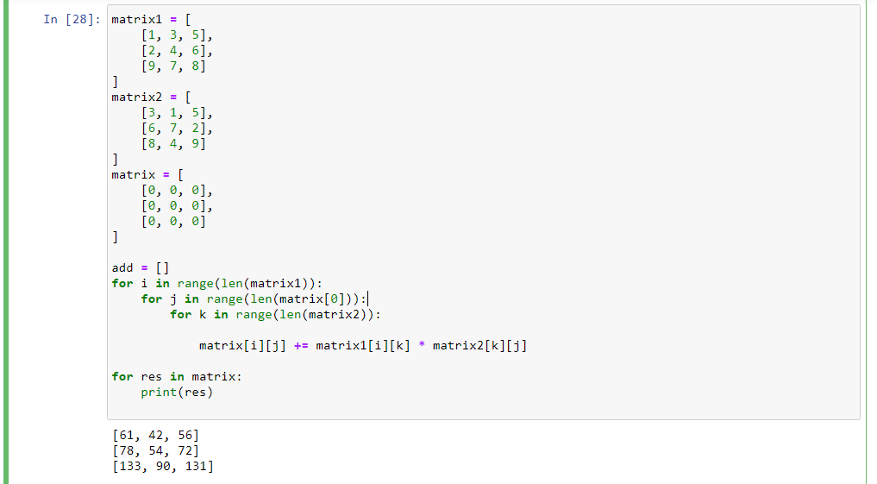

**4. Write a program to calculate the inverse of the given matrix.**

**Code:-**

import numpy as np

matrix = np.array([

[1, 2], [3, 4]

])

result = np.linalg.inv(matrix)

print(result)

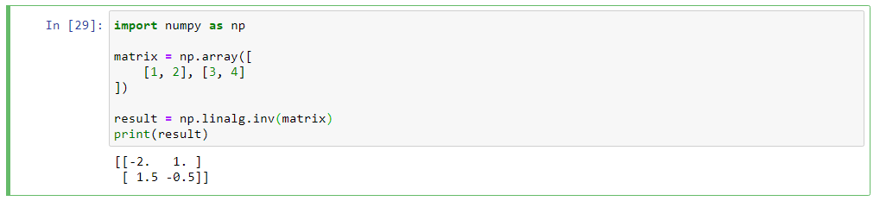

**5. Write a program to calculate the transpose of the given matrix.**

**Code:-**

matrix1 = [

[2, 4],

[3, 6],

[11, 2]

]

res = [

[0, 0, 0],

[0, 0, 0],

]

for i in range(len(matrix1)):

for j in range(len(matrix1[0])):

res[j][i] = matrix1[i][j]

for r in res:

print(r)

